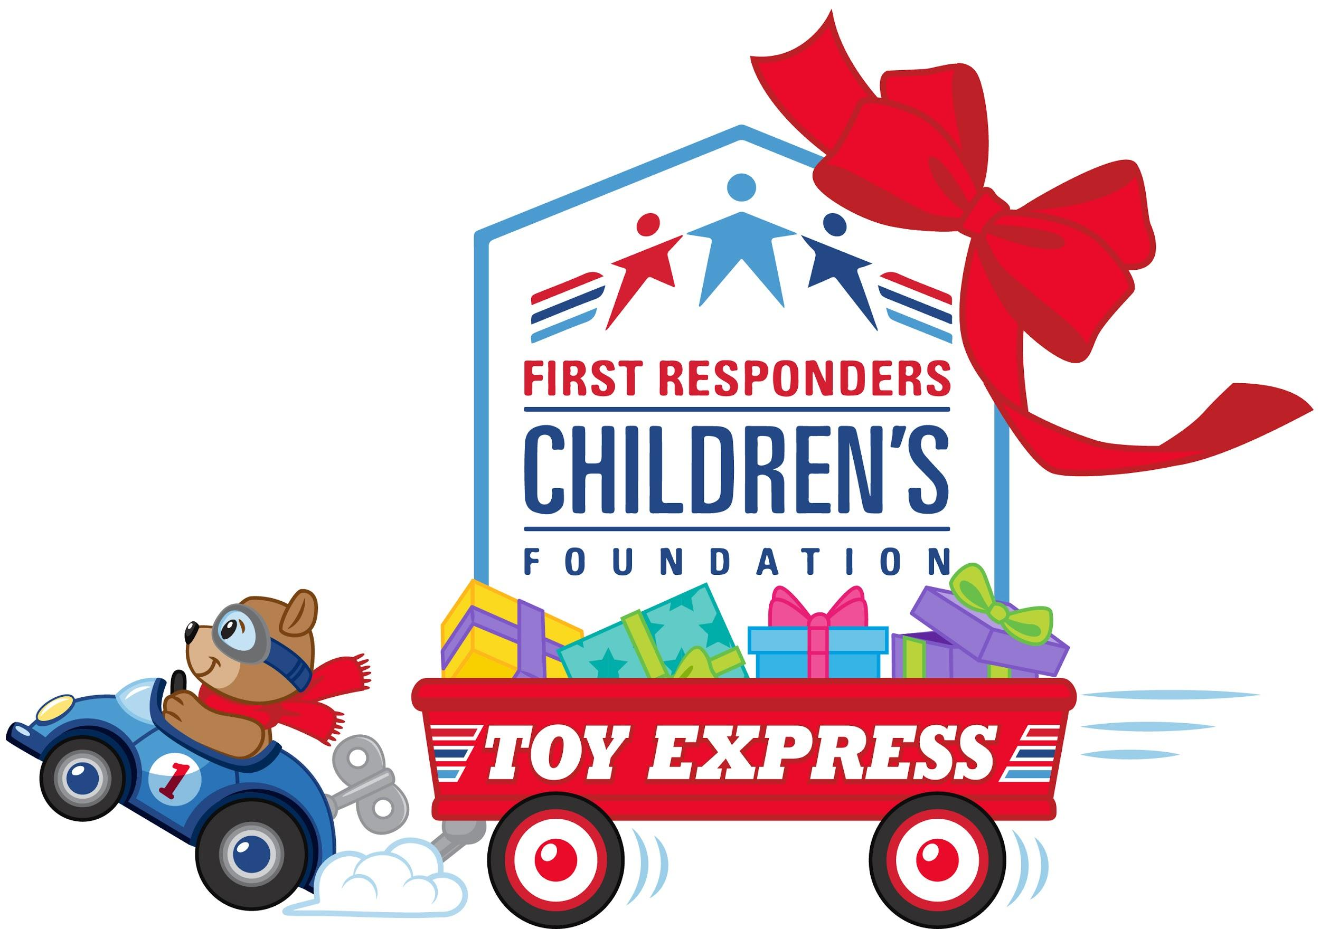

FOR IMMEDIATE RELEASE

FIRST RESPONDERS CHILDREN’S FOUNDATION FIRST ANNUAL
TOY EXPRESS DELIVERS TOYS TO FIRST RESPONDER FAMILIES AND FIRST RESPONDER AGENCIES OF [insert city and state]

[City, STATE] (Date, 2020) – Today, First Responders Children’s Foundation, a nonprofit organization that supports children of first responders and their families, announced that they would deliver toys to children in [insert city and state].

First Responders Children’s Foundation’s Toy Express will deliver more than 250,000 free toys and masks to first responder agencies and hospitals which will then distribute the holiday cheer to children of first responders and to children in first responder communities. Every child will also receive a mask with their toy.

“We’re saying happy holidays and thank you to the heroic first responders who show up when we dial 911,” said Jillian Crane, President of First Responders Children’s Foundation. “Toy Express will help make a happy holiday for the children of our first responders which include nurses, firefighters, police officers, EMTs, paramedics, medical personnel, and 911 dispatchers. Our first responders are on the frontlines of the pandemic, and they continue to risk their own health every day in selfless service to their local communities across the country. So, please help us help them. You can send toys & masks at 1stRCF.org or by texting TOY to 24-365.”

First Responders Children’s Foundation established the Toy Express with a generous toy donation worth more than $1,000,000 in retail value from Mattel and American Girl
including 5,000 signature 18” American Girl dolls and more than 45,000 in other Mattel products such as Hot Wheels®, Barbie® and Mega Bloks®. Additional sponsors include CSX, Good360, Hess Toy Truck, Jakks Pacific, MaskUSA.com, and Toys for Tots. In addition, generous individuals across the nation are helping bring holiday cheer to first
responder families by making donations of toys and money. Transportation of toys and masks across the country is coordinated and provided by Total Quality Logistics (TQL) and their Moves that Matter program.

Toys will be distributed to local children with the help of [insert your agency name] through [insert specific details of agencies program].

First Responders Children’s Foundation began in the wake of 9/11 when Founder and Chairman, Alfred R. Kahn, hosted the first annual Thanksgiving Day Parade Breakfast just weeks after the 9/11 attacks. That year, more than 800 children and family members of first responders lost in the line of duty were invited to watch the Thanksgiving Day Parade from private, front-row viewing which began an annual tradition of welcoming devastated first responder families into a supportive environment to face the challenges of the start of a holiday season without a loved one. 19 years later, the Foundation continues to support the families of first responders across the country with critical assistance including college scholarships and financial grants including paying for funeral bills of first responders who made the ultimate sacrifice in service to their community. During the 2020 pandemic, the Foundation has assisted more than 677,638 first responders through its COVID-19 Emergency Response Fund. This holiday season, First Responders Children’s Foundation’s Toy Express will help provide cheer and happiness to children and families of first responders. Media assets for Toy Express can be found at https://1strcf.org/toy-express/.

Media Contact:
Joanna Black
+1 (646) 912-2681
Joanna@1stRCF.org

